**What is bootloader and why we need it?**

Bootloader is small piece of executable code that permanently stored in the microcontroller’s memory. This occupies less than 1Kb of memory. Bootloader allows the IC to accept the code from the computer and place it in the memory of the microcontroller.

Traditionally, all the microcontroller from Atmel are programmed with the help of programmers which has some fancy connections. Bootloaders reduces the complexity and allow us with an easy and efficient way of programming the microcontroller. This means you can program it just by using an USB cable.

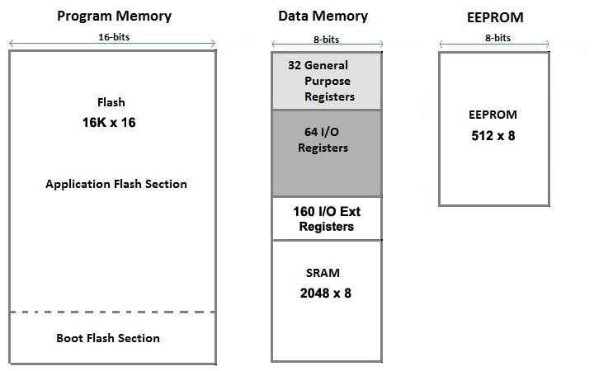

**Load the sketch**

**The Arduino that you will use as programmer needs a specific sketch.**

**Step 1:** Open Arduino IDE. Go to **File** -> **Examples** ->**11. ArduinoISP** and choose ***ArduinoISP***.

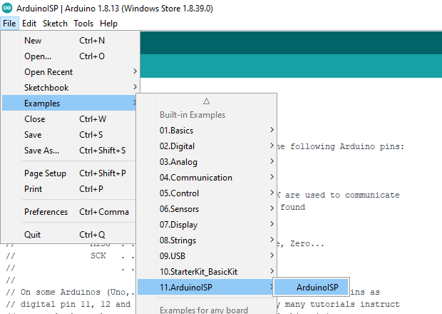

**Step 2:**Now, you have to upload this code to your **Arduino board**. Choose the **com port** and **board** from the **tool menu** and hit the **upload** button.

**Step 3:**After ‘**Done uploading’**, disconnect the Arduino board from the computer and make the connections of Arduino board with Atmega 328 as shown in below diagram.

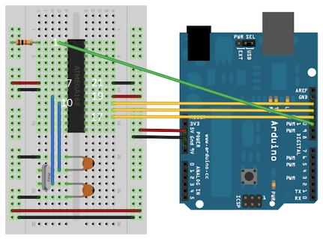

**Components Required**

- 16 MHz crystal

- 10 k resistor

- 18 to 22 picofarad (ceramic) capacitor (**two pieces**)

**Step 4:**Now, connect the Arduino board with the computer. Open Arduino IDE.

Go to **Tools**, choose board **as Arduino/Genuine Uno**, Choose the correct **Port** for your board. Choose **Programmer as “Arduino as ISP”**. Don’t confuse it with ArduinoISP. Both are different.

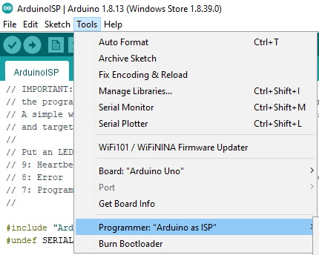

**Step 5:**Now, Go to **Tools** again and Click on **Burn Bootloader** just below the Programmer option. After few seconds, bootloader is uploaded successfully.

(If there is any error in uploading, check the connections.)

Ref : <https://www.arduino.cc/en/Tutorial/ArduinoToBreadboard>

Ref : <https://circuitdigest.com/microcontroller-projects/how-to-burn-bootloader-in-atmega328p-and-program-using-arduino-ide>